LAKESIDE X
Rider 2023

SOUND & LIGHT CREW
The venue agrees to provide necessary sound and lighting system, the necessary sound/lighting crew/operators throughout entire stage presence (soundcheck and actual performance).

DRESSING ROOM & HOSPITALITY
The Promoter agrees to provide for the artist's sole use and for the duration of the engagement until curfew, comfortable dressing room to house 4 people. For catering the band expects a sandwich platter or a pizza,
10 + 5 alcoholic/non-alcoholic beers and still water.

PROJECTION
- A projector with minimum of 5000 Lumens (or LED wall) must be provided by the venue
- projection screen should be at minimum 3m x 2m
- If projector is used, it must be capable of HD output
- projection is controlled by the band from stage
- HDMI connection must be provided from stage

STAGE PLOT

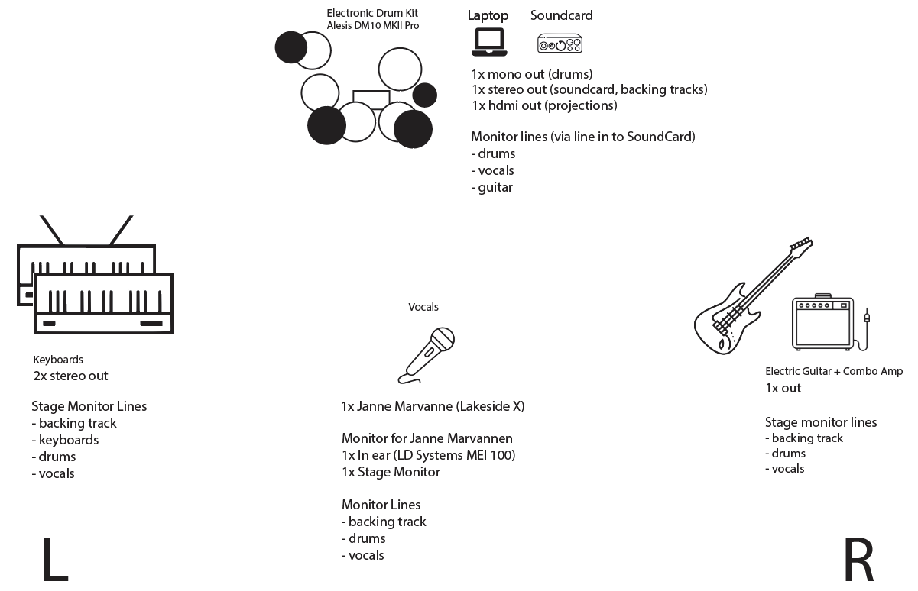

IN-HOUSE LIGHTS
Band will provide simple printed instructions to the lighting technician for lighting approach for live performance.

ADDITIONAL EFFECT LIGHTS
- Band is bringing a set of effect LED Bars that are completely controlled by the band from stage
- All the necessary stands, trusses, power and dmx cables are provided by the band
- The only requirement is to provide 3 power outlets (for DMX splitter and LED bars power chain)
- Depending on the stage size the lights may be installed on trusses or standalone tripods. Please consult with the band in case stage dimensions do not allow the effect lights to be installed as shown on the diagram bellow.
